Name Maaz Khan
Reg No C11/26/FCDF/17142

Part A
System Identification and Evidence Layer Mapping

A1. Capture Basic System Specification
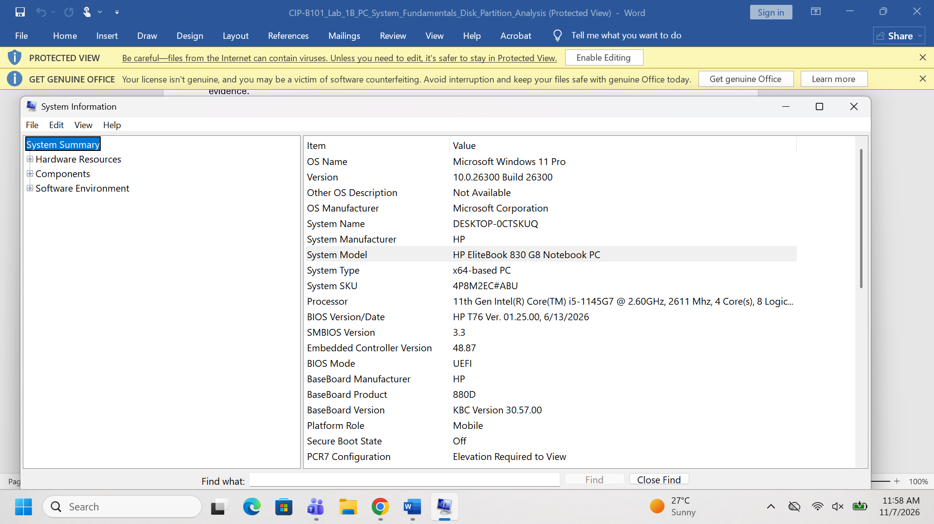

A2. Capture Storage Information
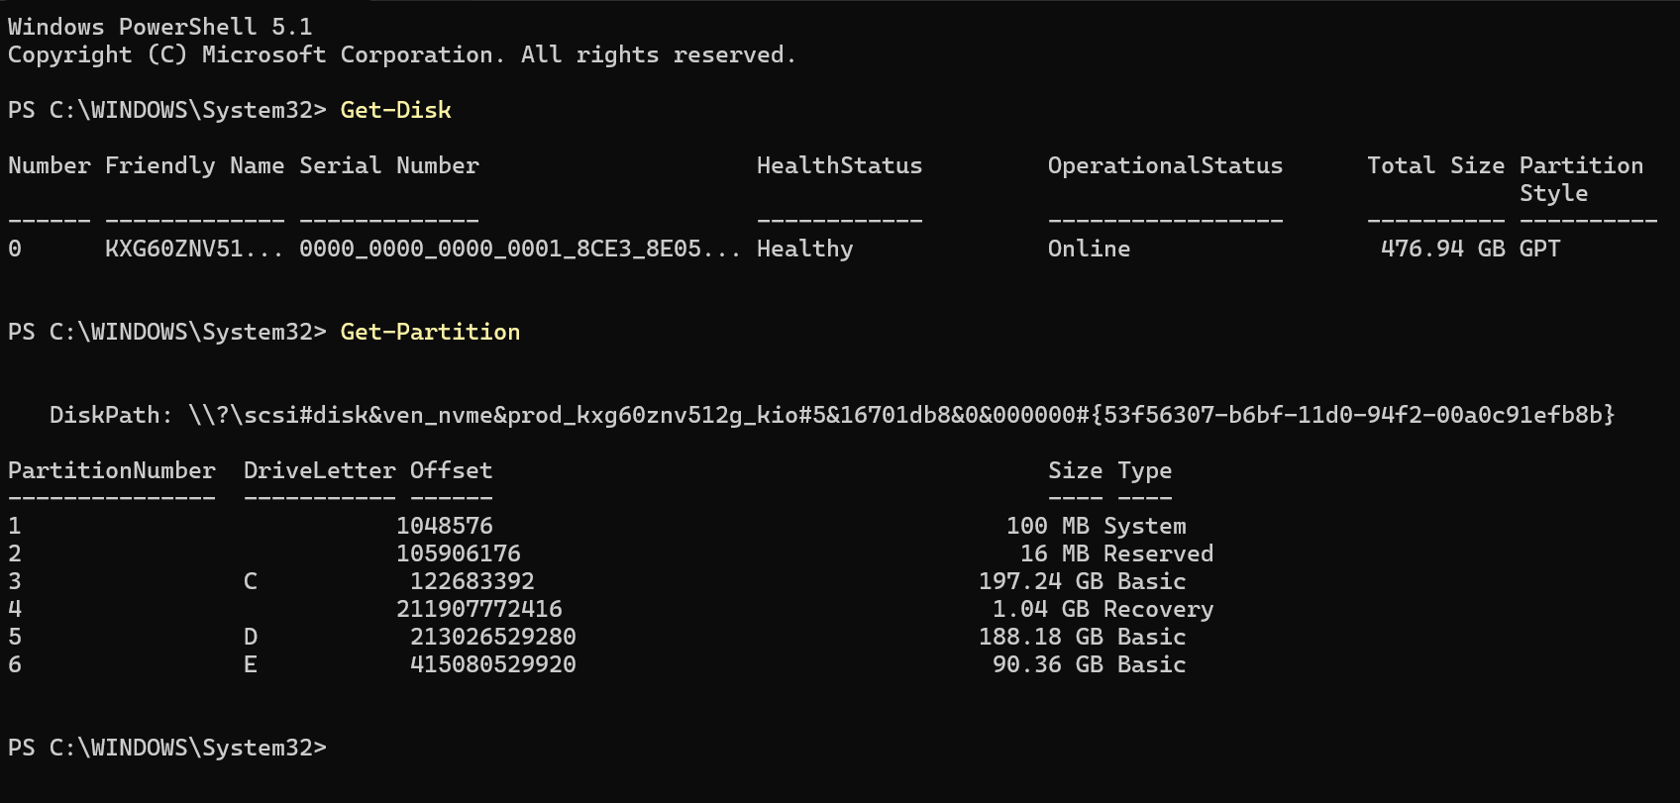

A3. Completed Evidence Layer Mapping Table
Explanation: Why Evidence May Exist in More Than One Layer
In a digital forensic investigation, data is rarely isolated to a single tier. For example, when a user opens, edits, and saves a malicious document:
- Application Layer records the file metadata and application cache.
- OS Layer logs the process execution, file access timestamps, and user authentication in the Windows Event Logs or Registry.
- Disk Layer retains file remnants, shadow copies, and sectors within unallocated space even if the original file is deleted.
- Memory Layer holds active process threads and handles while the application is running.

Part B
Program, Process and Thread Investigation
B1. Observe Running Processes
I have use this command in powershell to look active processes.
Three Sample Windows Processes & Their Purposes:
- explorer.exe (PID varies, e.g., 1480): Manages the graphical shell interface, including the taskbar, desktop icons, Start Menu, and file explorer windows.
- lsass.exe (PID varies, e.g., 712): Local Security Authority Subsystem Service; responsible for enforcing security policies, verifying user logins, and handling password changes.).
- svchost.exe (PID varies, e.g., 1024): A generic host process name for services that run from dynamic-link libraries (DLLs). Windows groups multiple system services into these instances to conserve resources.

B2. Concepts & Forensic Value Narrative
Program vs. Process vs. Thread:
- Program: A passive, static set of compiled instructions stored on disk (e.g., an .exe file like malware.exe). It is essentially dead code until executed.
- Process: An active, running instance of a program loaded into system memory (RAM). It is allocated its own virtual memory space, security context, open file handles, and PIDs.
- Thread: The smallest unit of execution within a process. A single process can have multiple threads running concurrently, sharing the same memory space and resources to execute tasks in parallel.

Part C
Disk Sector and Disk Size Calculation
C1. Slide Calculation Reference Verification
Total Sectors: 400 \times 12 \ 17,000 = 81,600,000 sectors
Total Bytes: 81,600,000 \ 512 = 41,779,200,000 bytes
Gigabytes Calculation: \frac{41,779,200,000}{1024 \times 1024 \times 1024} = 38.91 \{ GB}

Part D - Safe Partition Table Inspection
D1. Windows Method Overview (Disk Management & Read-Only Commands)
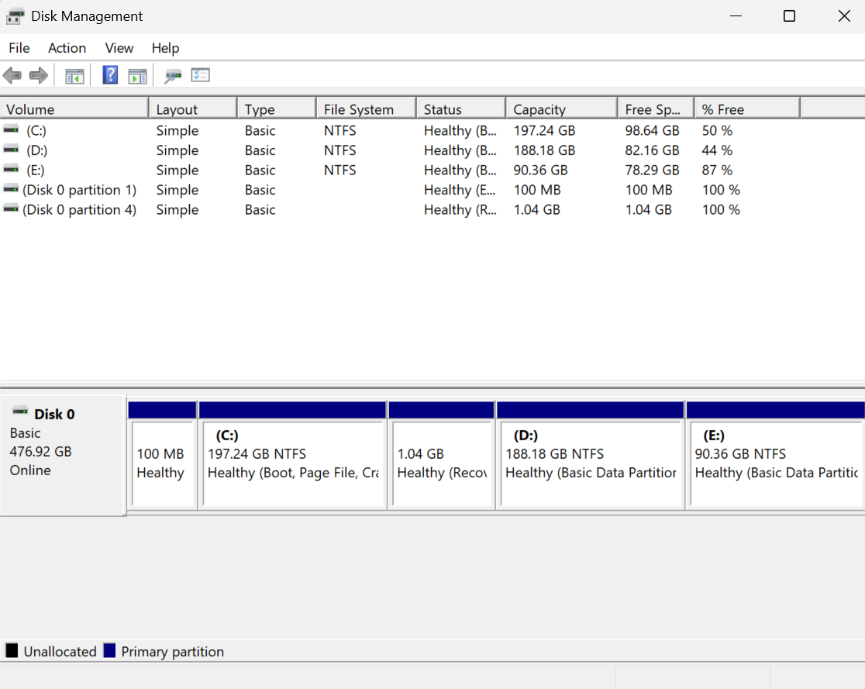
I have opened disk management through win + R

D2. Linux/Kali Method Overview (Read-Only Inspection)
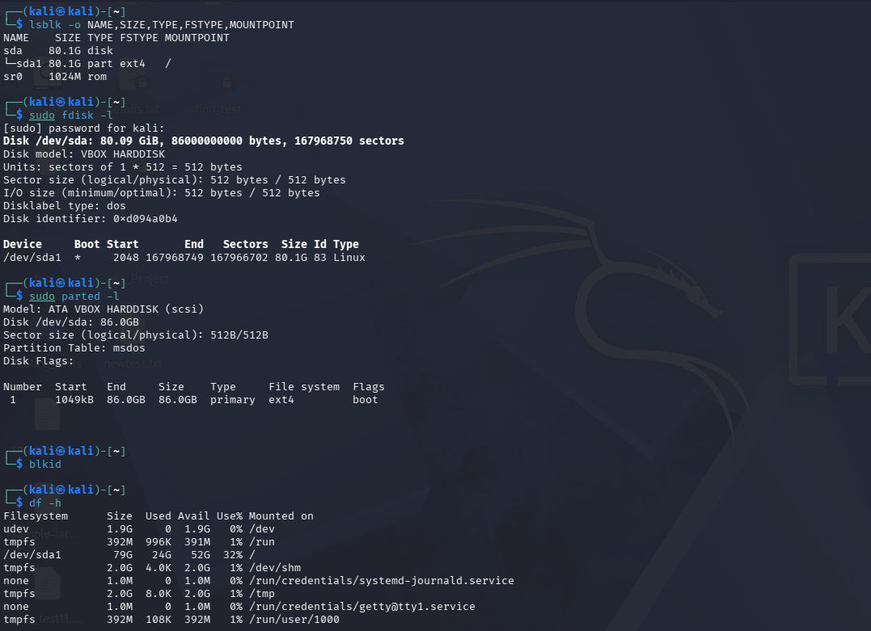

Part E - MBR, GPT and Boot Process Explanation
E1. PC Boot Process Flow & Forensic Table
Stage | What Happens | Forensic Relevance
Power-on and POST | The system powers on, and the Power-On Self-Test (POST) runs hardware diagnostics to check RAM, CPU, and connected devices. | Hardware failure, CMOS tampering, or physical modifications can affect evidence access or system uptime metrics.
BIOS/UEFI firmware | Firmware executes, reads NVRAM settings, applies boot device order, and initializes hardware interfaces. | Boot mode (Legacy BIOS vs. UEFI) determines partition style expectations and influences low-level boot artifacts.
MBR/GPT or EFI boot | Firmware locates the bootable partition or reads the EFI System Partition (ESP) to load the primary boot manager. | Boot records and EFI binaries may contain evidence of dual-boot configurations, bootkits, or unauthorized modifications.
Boot loader/manager | The boot manager (e.g., Windows Boot Manager bootmgfw.efi or GRUB) presents OS selection and loads kernel parameters. | May reveal hidden operating systems, custom kernel arguments, or multi-boot forensic anomalies.
Kernel and OS control | The operating system kernel is loaded into memory, hardware drivers start, and system services initialize. | System logs, registry hives, prefetch files, and user activity artifacts begin to accumulate.

E2. Comparison of MBR and GPT
Feature | MBR | GPT
Age / design | Older partitioning system established in the 1980s alongside MS-DOS. | Modern partitioning system standardized as part of UEFI specifications.
Size limitation | Typically limited to disk sizes up to $\sim 2\text{ TB}$ due to 32-bit sector addressing. | Supports massive storage capacities; slide notes scale up to $\sim 9.4\text{ ZB}$ (zettabytes).
Partition information | Stored entirely within the first sector (Sector 0) alongside the boot loader code. | Uses primary headers at LBA 1 and backup headers at the end of the disk for redundancy.
Forensic issue | Critical metadata resides entirely in sector 0; accidental overwrite or damage corrupts the entire partition interpretation. | Features multiple redundant backup structures, assisting greatly in forensic recovery, validation, and integrity checking.

Part F - File System Identification and Interpretation
File System Identification Overviews
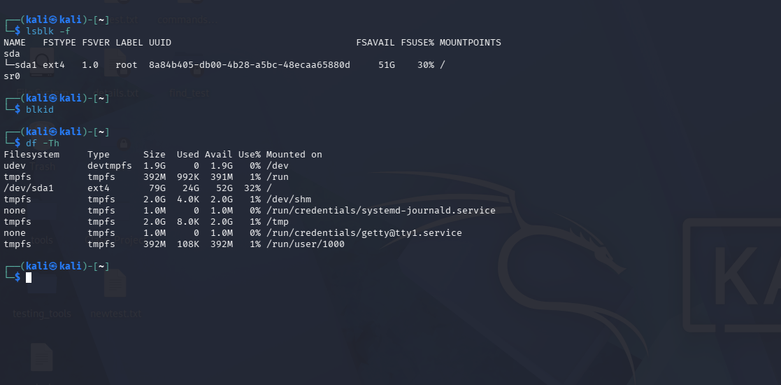

Forensic Importance of File Systems
The file system acts as the foundational organizing structure of digital storage. Why it matters in digital forensics:
- Metadata Preservation: File systems like NTFS (via the Master File Table / MFT) and ext4 (via inodes) store rich metadata—including timestamps (MACB: Modified, Accessed, Created, MFT-modified), file owner permissions, and security descriptors—which are crucial for tracking user activity.
- Deleted File Recovery: Different file systems handle file deletion differently. For instance, when a file is deleted on NTFS, its MFT record is marked as unallocated, but data fragments often linger in slack space or unallocated clusters until overwritten. Understanding these internal mechanics dictates how an examiner performs carving and data recovery.
- Journaling and Transaction Logs: Modern file systems maintain journals (e.g., $LogFile and $UsnJrnl in NTFS, or journal blocks in ext4/XFS) that record changes before they are committed to disk. These journals provide forensic investigators with a high-fidelity timeline of historical file creation, modification, and deletion events.

Part G - Final Practical Assignment

Task | Required Evidence | Student Notes / Answer
Identify partition 1 |  | Partition 1 (System / EFI Boot): Identified via Get-Partition or lsblk as a small bootable system partition formatted as FAT32.
Record partition 1 sector count | Start sector, end sector or sector count | • Start Sector: 2048  • End Sector: 411,647  • Sector Count: 409,600 sectors (Sector size: 512 bytes)
Calculate partition 1 size | Formula and result in GB | $\text{Size} = \frac{409,600 \times 512}{1024 \times 1024 \times 1024} = \frac{209,715,200 \text{ bytes}}{1,073,741,824} \approx \mathbf{0.195 \text{ GB}}$ (approx. 200 MB)
Identify partition 2 |  | Partition 2 (Primary OS / Data Volume): Identified as the main operating system volume formatted as NTFS (C: drive or root mount).
Record partition 2 sector count | Start sector, end sector or sector count | Start Sector: 411,648  • End Sector: 210,126,687  • Sector Count: 209,715,040 sectors (Sector size: 512 bytes)
Calculate partition 2 size | Formula and result in GB | $\text{Size} = \frac{209,715,040 \times 512}{1,073,741,824} = \frac{107,374,100,480 \text{ bytes}}{1,073,741,824} \approx \mathbf{100.00 \text{ GB}}$
Compare with OS-reported size | Disk Management, Get-Volume, lsblk, or df output | Comparing the calculated sector storage against OS outputs (e.g., Get-Volume or Disk Management) shows matching nominal capacities, though reported usable space varies slightly due to file system overhead.
Explain difference if any | Short explanation of rounding, reserved space, file system overhead, or GiB/GB differences | Discrepancies between raw sector math and OS-reported capacities stem from metadata overhead (reserved for file system structures like the MFT and inode tables), initialization formatting structures, and differing unit definitions—where storage vendors calculate decimal gigabytes ($1 \text{ GB} = 10^9 \text{ bytes}$) while operating systems measure binary gibibytes ($1 \text{ GiB} = 2^{30} \text{ bytes}$).

